Written description of three observable trends based on the data from part 1:

1. Following figure shows us the Humidity is mostly around or below 100 in all the cities mentioned:

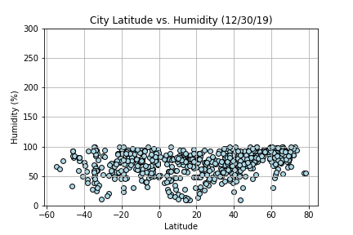

1. Based on the Latitude from -60 to 80, the cloudiness in scattered between 0 to 100.

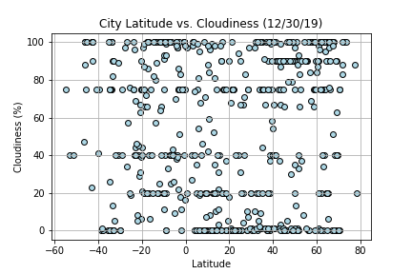

3. The following figure shows the Maximum temperature the highest in the cities around -40 to 20 latitude, as the latitude increases, the temperature drops.

